* PROJECT TITLE – WanoTag
* TEAM NAME - Kismet
* PROJECT OVERVIEW
  + 2-4 Player Adverserial Tag Game with online multiplayer and a customisable selection of varied skills & movement options for third person characters.
* TEAM MEMBER ROLES
  + Ludo West – UI/Programming
  + Joe Mason – Network Programming
  + Sid Weston – Gameplay Programming
  + Ioannis Kontes – Character Modelling & Animation
  + Dan Drury – Prop & Level Designer
  + Ted Arnott – Level Designer
* KEY DELIVERABLES
  + Full build of game, video demonstration of gameplay, game trailer and complete HacknPlan
* PROJECT GOALS
  + - 2-4 Player Network Connectivity.
    - Third person character movement system.
    - A wide selection of movement options for players to choose 3 of.
    - Several game-modes based around tagging other players using said abilities.
    - At least 4 character choices.
    - Different urban-style maps for players to engage in each match.
* TARGET AUDIENCE
  + People that enjoy fast-paced competitive games that require quick reaction times and quick thinking.
  + Groups of friends looking to play something online together to socialise with each other.
* DELIVERY PLATFORMS
  + PC-exclusive game with controller support.
* SOFTWARE REQUIREMENTS
  + Unity
  + 3DS MAX
  + Substance Painter
* UX
  + Lots of feedback upon significant actions to let players know what’s happening in the game space.
  + Getting playtest data to see what parts of the UX need improving.
* SCHEDULE Of ACTIVITIES
  + Character Models
  + Level Props & Design
  + Netcode
  + Character Controllers
  + Ability Code
  + Menus
  + Gameplay Trailer
  + Character Animations
  + Particle Effects
  + Game Loop Code
* APPENDICES
  + Initial concept art, mood boards, wireframes, flow diagrams could be included here.

*Potential Key-Art Compositional Reference*

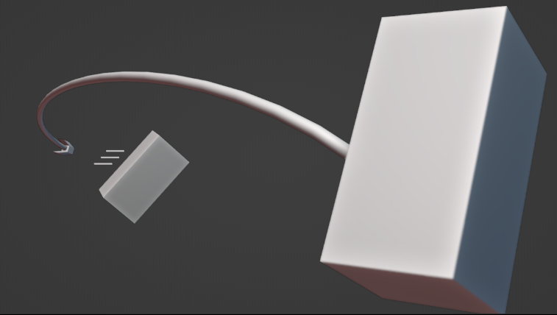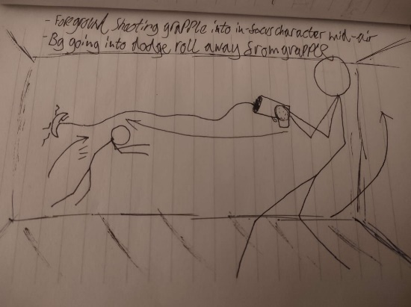

*Character Design Style Moodboard, Techwear & Covered Faces*

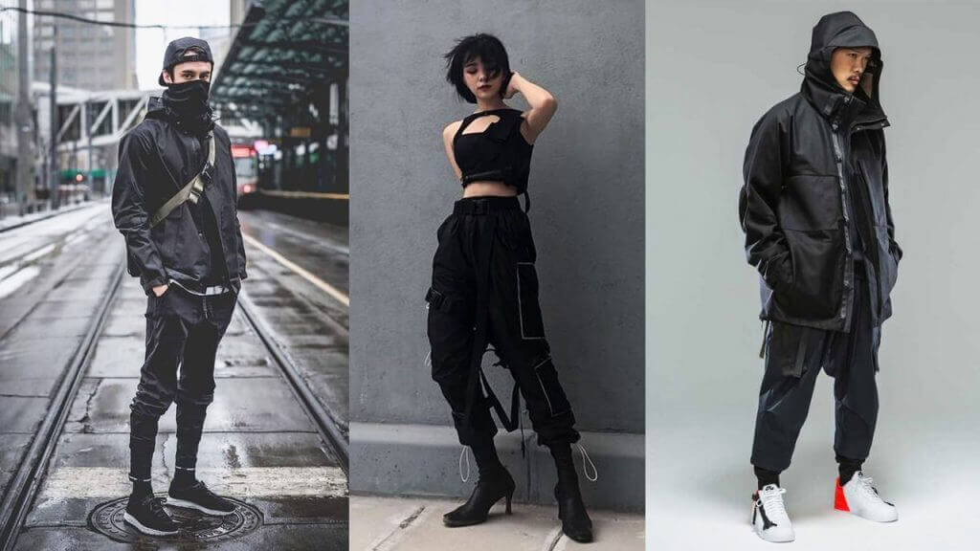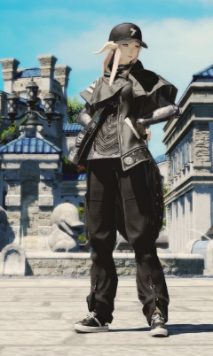

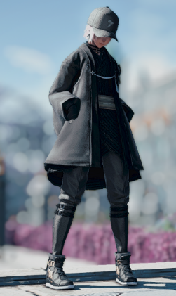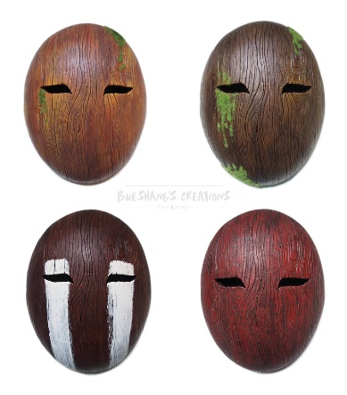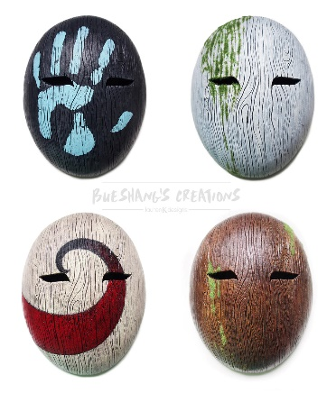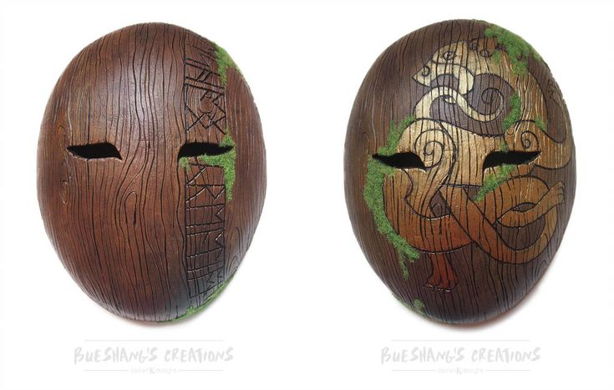

*Map Ideas Moodboard*

